**Understanding In-app Ads and Detecting Hidden Attacks through the mobile App -Web Interface.**

Table of Contents

I. Project Details 5

II. Requirement Specification for Phase - 1 6

1. Functional Requirements Developed under Phase – 1 with respect to each module 6

1.1 Admin Module Requirements: 6

1.2 User Module Requirement: 8

2. Non-Functional Requirements Developed Under Phase - 1 12

2.1 Security Requirements: 12

2.2 Privacy Requirements: 12

2.3 Scalability and performance Requirements: 12

2.4 Usability Requirement: 12

2.5 Compatibility Requirement: 12

3. Interfaces (user, hardware, software, and/or communication) Developed Under Phase - 1 12

3.1 Hardware Interface Requirements: 13

3.2 Software Interfaces Requirements: 13

3.2 User Interface: 13

III. UML Design 16

1. Class diagram 16

2. Sequence diagram 17

3. Use case diagram 18

IV. Test Cases 20

V. User Manual for Phase - 1 31

VI. Program Compilation and Run Instructions 55

1. Program Instructions 55

2. Testing Instructions 56

VII. Feedback 56

VIII. Accomplishments 57

IX. Member contribution table 57

# Project Details

**Project Title: Project Title:**  **Understanding In-app Ads and Detecting Hidden Attacks through the mobile App -Web Interface.**

**Group Name:** Team Resolve

**Group Members:**

1. Navyasri Arekatla
2. Lokesh Bachu
3. Sushma Bobbishetty
4. Naveen Bolgom
5. Sathvik Cheekati
6. Vamshi Teja Goud Puli
7. Shiva Teja Reddy Yammanuru

# Requirement Specification for Phase - 1

# Requirement Specification for Phase - 1

## Functional Requirements Developed under Phase – 1 with respect to each module

### Admin Module Requirements:

#### Registration/ Sign-up:

* We need to deploy the project and run the server.
* Admins have to register with the required information to register for the browser.
* The browser which we are using is Apache software.
* Admins can initially register with their organizations email id and password using the button “Admin Login” on the Main Page.
* Once they click on the button, Registration page will be displayed.
* Once the admin gets registered. We can login into the browser.

#### Login Validation:

* The administrator must log in by selecting the "Admin Login" button. Credibility checks have been done.
* If any of the information is wrong, the message "Invalid Username or Password" is displayed.
* • Whenever you want, you can use the "Forget Password" option to modify your password. There are blank spaces for the Email ID, Contact No., New password, and Confirm password fields. When provided with the correct Email ID and Contact Number, passwords are updated correctly. Selecting Cancel will stop the password update.

#### Dashboard Display:

Admin Dashboard has following sections:

##### ADMIN MENU:

. Admin menu consists of many options which can be operated by the admin.

Some of them are:

**View all users and authorize**: we can see all the user requests and authorize them. Only the authorized users which are made by the admin can have the access to the user dashboard.

**View all android users**: All the android users are displayed in this module.

**View advertisement request users:** The requests which are sent by the user for the advertisements are shown here. We can accept the request from this interface.  
 **View friend request and responses**: All the friend requests and responses are shown in this module.

**View All user’s advertisement with rank and rating:** All the user registers advertisements are displayed in this module with rank and rating of their advertisements.

**View all Malicious user’s details:** In this module, the malicious users details can be seen. This helps for the admin to know the details of the malicious users which he/she may not give access to the user for further advertising.

**View all advertisement recommended users details:** The advertisements which are recommended by the users are shown in this module.

Some of the operations in the admin dashboard which are commonly used are:

* View malicious publishers.
* View all android hidden attackers.
* View all expired advertisements.
* View all blocked users.
* View all blocked user’s evidence.
* View user type count in chart.
* View all advertisement ranks in chart.

**Logout:** Admin can log out from the dashboard by clicking this option

### 1.2 USER REGISTER MODULE Requirement:

#### Registration/ Sign-up:

* In order to use the browser, users are required to give the essential information during the registration process.
* Our web browser is powered by the Apache software.
* To begin, users can register by selecting the "User register Login" button located on the homepage, followed by providing the email address and password associated with their organization.
* Once they click the button, the page that prompts them to register will load.
* When a user first registers for an account. We are able to sign in thanks to the web browser.

#### Login Validation:

* The dashboard shows the option to login for the User. We need to register to the portal by giving required details. Once we register we can see the status as registration successful, we can now login into the user module.
* User should click on “USER” option from the dashboard and enters his/her login credentials.
* The User register must be authorized by the Admin.

#### Dashboard Display:

The User dashboard display is seen only when the admin authorizes the User request.

##### User menu:

User dashboard displays all the operations which can be performed by the user.

##### Profile:

In the profile, the person’s information is available.

###### Search friends:

We can search for the friends in this module and make new friends by the user. We can search for friends and send requests.

###### Manage bank accounts:

It displays the account details. We can enter the bank account details and register our own bank account in this module. We can also look our statement in this module.

##### send request to admin to launch advertisement:

* This section shows the date and time when we want to send the advertisement request and the admin has to accept the advertisement request.
* We need to make the payment for this advertisement.

##### add advertisement details:

Once the advertisement request is accepted by the admin we can now add the details of our advertisement in the given browser.

It asks for some details such as category, name, file, content and the time duration of the advertisement in the browser.

##### view all my advertisement details:

In this module we can view the posted advertisements and the duration of the Ad.

* We can also delete the advertisement whenever we want to delete it.

##### all my friends advertisement details and recommend to other friends:

In this module, we can view our friends advertisements and recommend them to other friends.

##### friends recommended advertisements:

We can view the advertisements which are recommended by our friends and If we want them to advertised, We can put on a request to the admin.

##### Logout:

User can logout just by clicking this button.

## Non-Functional Requirements Developed Under Phase - 1

### Security Requirements:

Security of the application is maintained by using java functions and the JavaScript’s in the HTML file of the application for user authentication and The project can be run on any website ,if not it’s not going to be accessed.

### Privacy Requirements:

The application doesn’t show any personal information of users apart from the email id that will be used while registering. We will be using Java Script for Authenticating the login credentials.

### Scalability and performance Requirements:

In this application , people work on complete web page for their advertisement and some relationship maintenance with peers in the framework and it is completely web based so we need to build this on having a domain and cloud server for the application.

This application resembles the main project and implementations in higher level.

### Usability Requirement:

Usability of the application is also an important thing in building an application for the user. To make the application more user friendly we are using ajax and jQuery and Java for fluent handling of functions from backend to front end.

### Compatibility Requirement:

Running our application on following browsers is more compatible :

1. Chrome Browser Version 98.0.0.0 or above
2. Microsoft Edge Version 90 or above
3. Safari Browser Version 13.1.2 or above

## Interfaces (user, hardware, software, and/or communication) Developed Under Phase - 1

### Hardware Interface Requirements:

This application can be runed on a web browser which is installed on **Laptop / PC**.

### Software Interfaces Requirements:

1. **HTML**: For website Designing.
2. **JQUERY:** For styling the website Design.
3. **AJAX:** Used for Dynamically loading the webpages.
4. **JavaScript**: This Technology is used to apply validations for web pages and redirections etc.,
5. **SQL:** We will be using SQL for accessing the database.
6. **Visual Studio:** We will be using Visual Studio as Integrated Development Environment for the Project.
7. **Apache Tomcat:** It is used as a server for deploying the application.

### User Interface:

Here is the Landing page of the application.

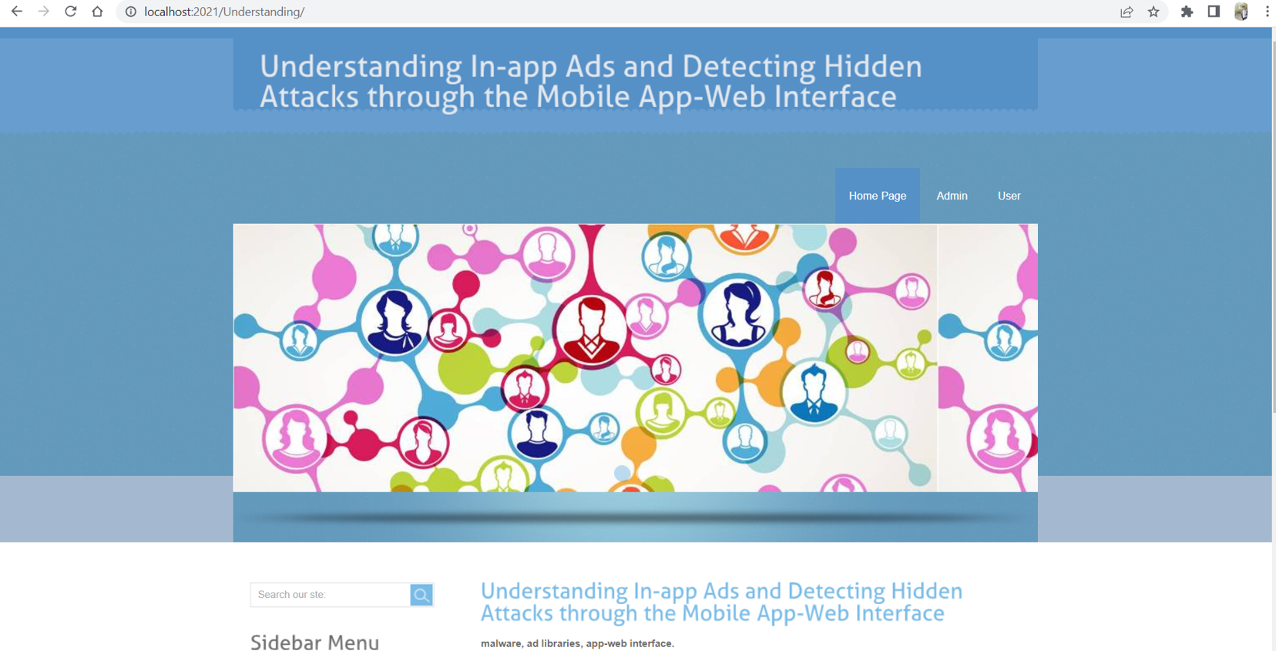

Step 2: This page displays the menu options like Home, Admin, User

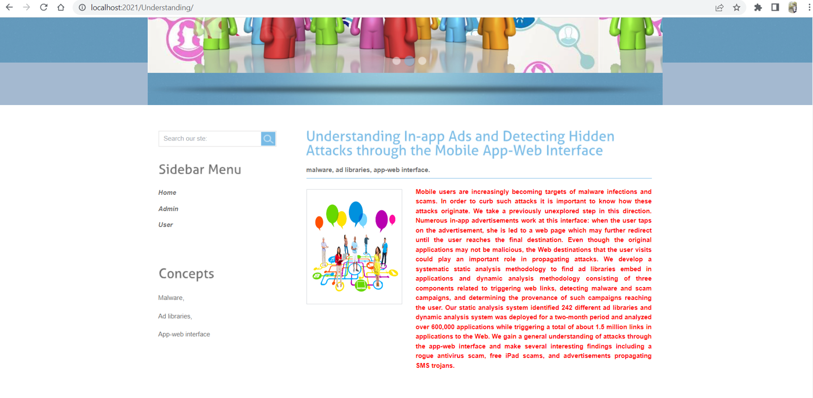

Step 3: By selecting the user from the menu we can land into this page. That is User Login page. As the new user we need to select Register here.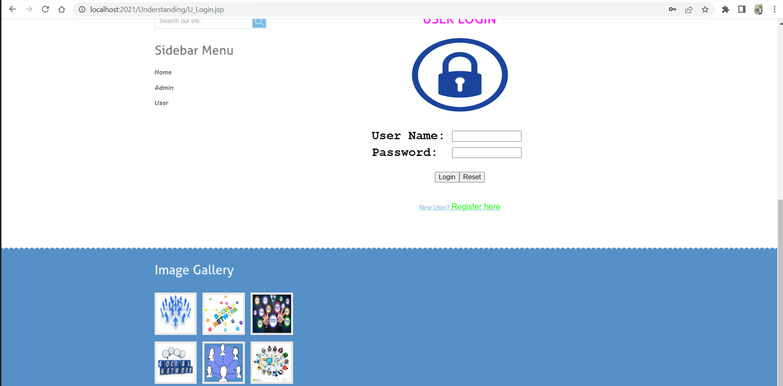

Step 4: By selecting the register here, we need to provide the details of the user.

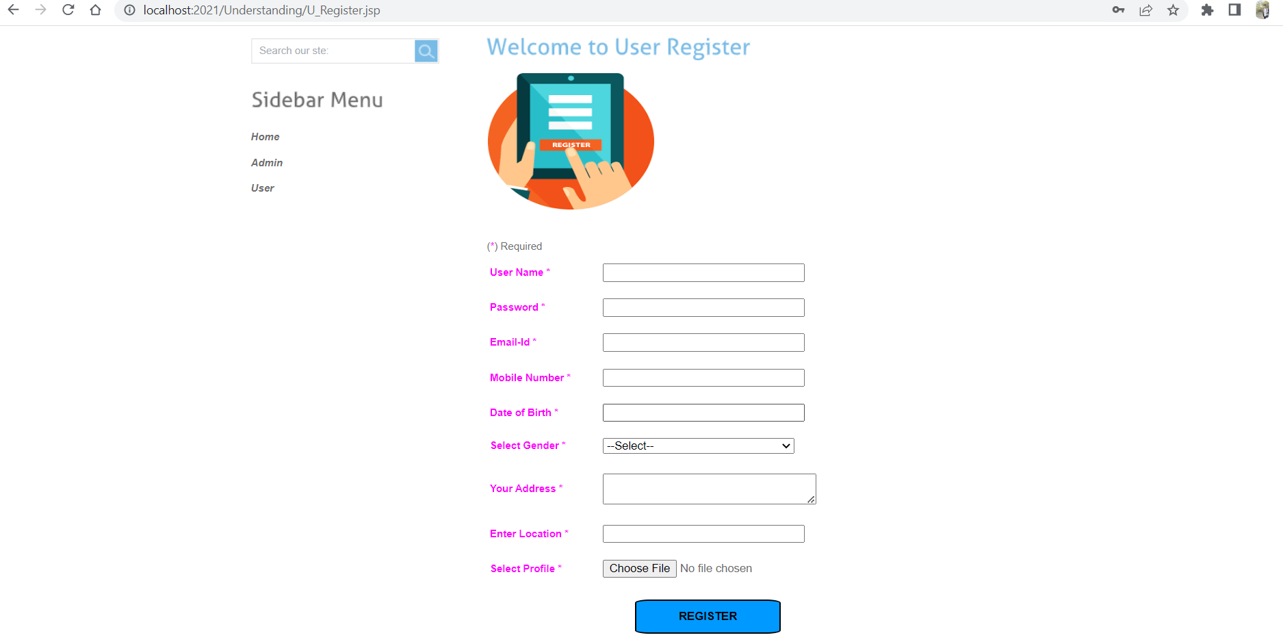

Step 5: In the below screenshot user details are displayed to register.

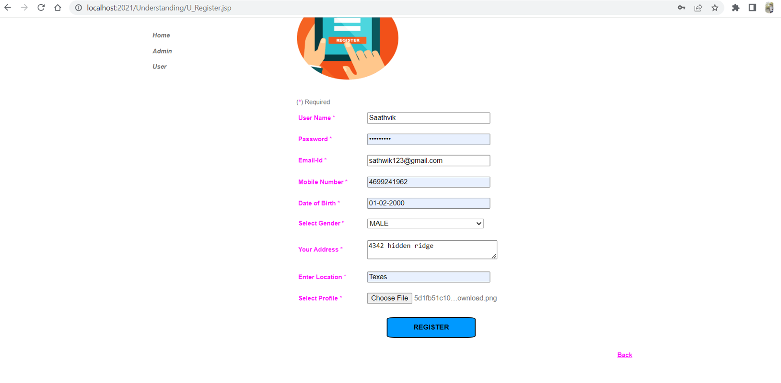

Step 6: This page going to display after the successful completion of the registration.

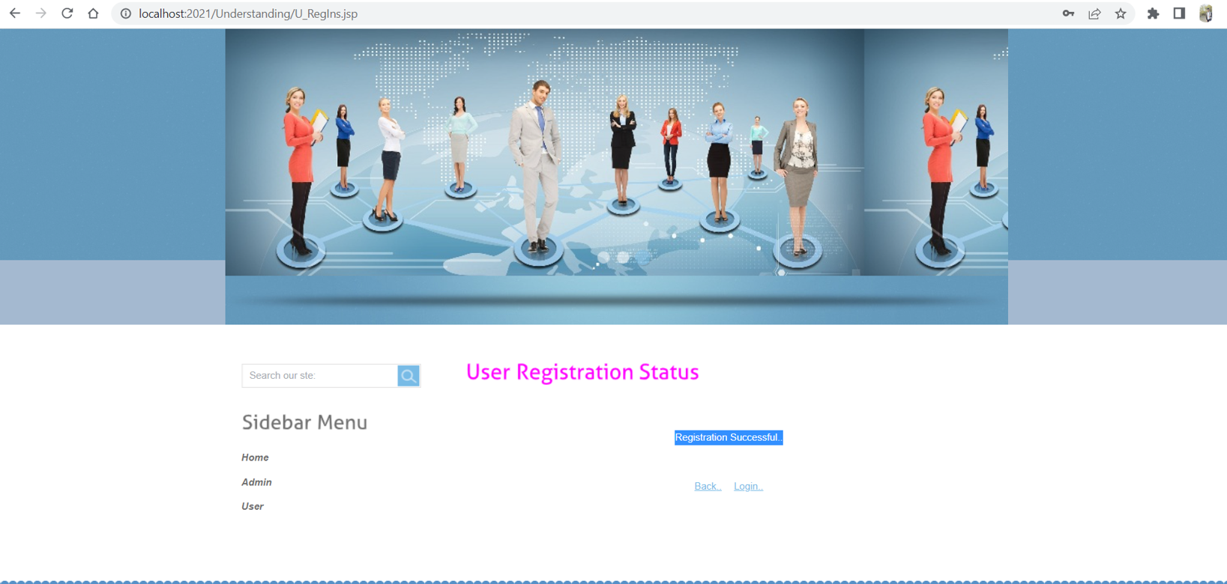

Step 7: Here is the User Login Page

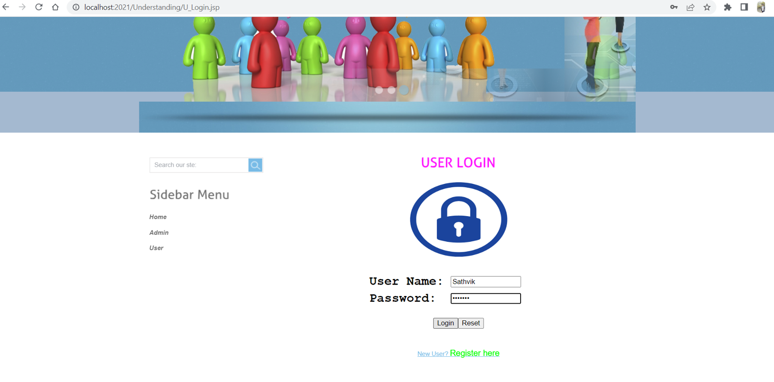

Step 8: Here is the Admin page of the application.

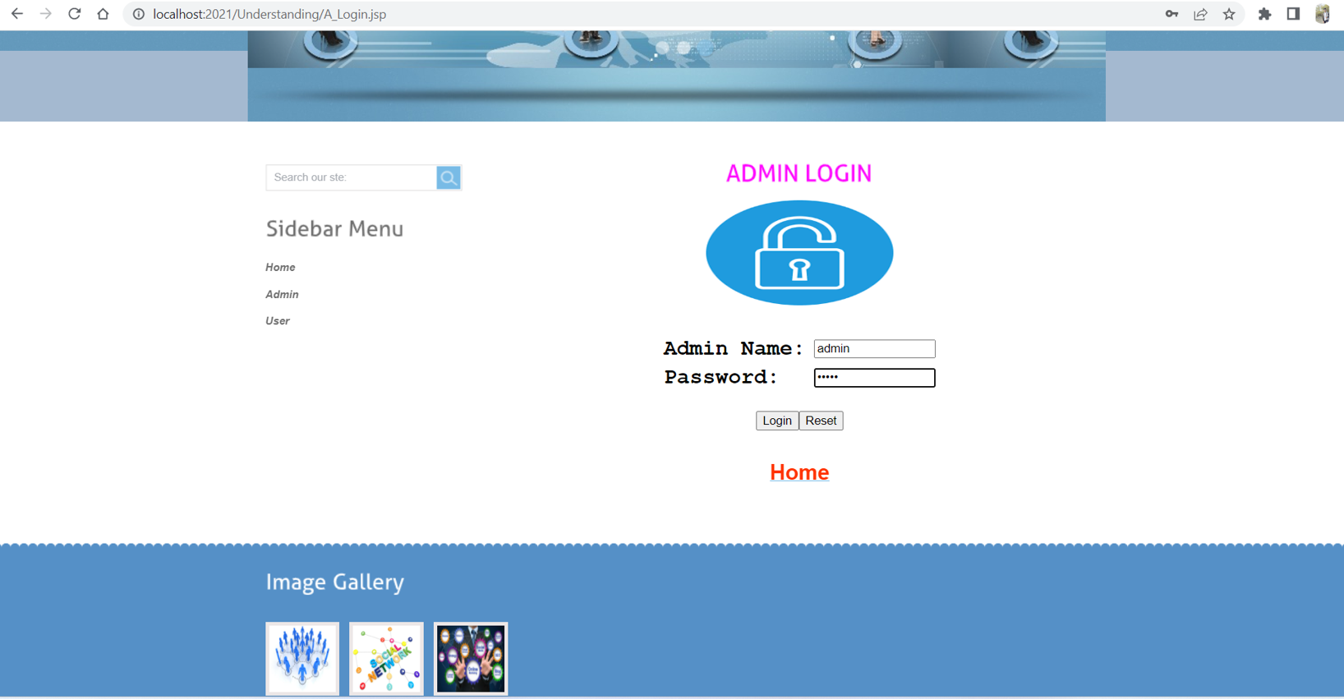

Step 9: In the below screenshots it displays the home page of the admin page.

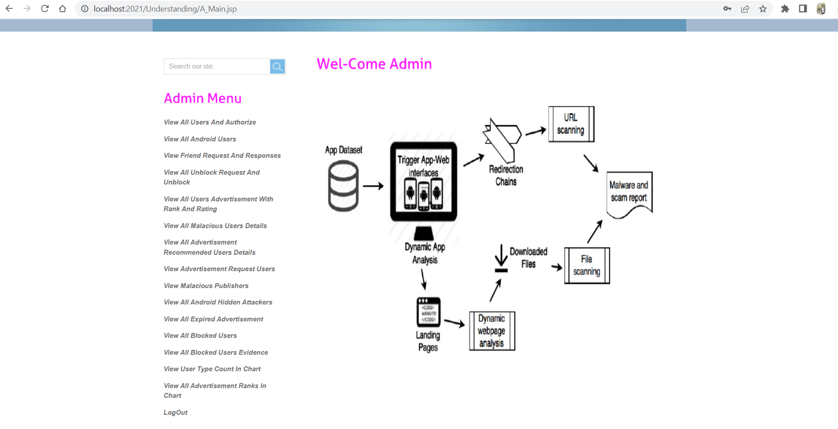

Step 8: By selecting the View All Users And Authorize it will display the below page. Here, the admin needs to authorize the user for login to this application.

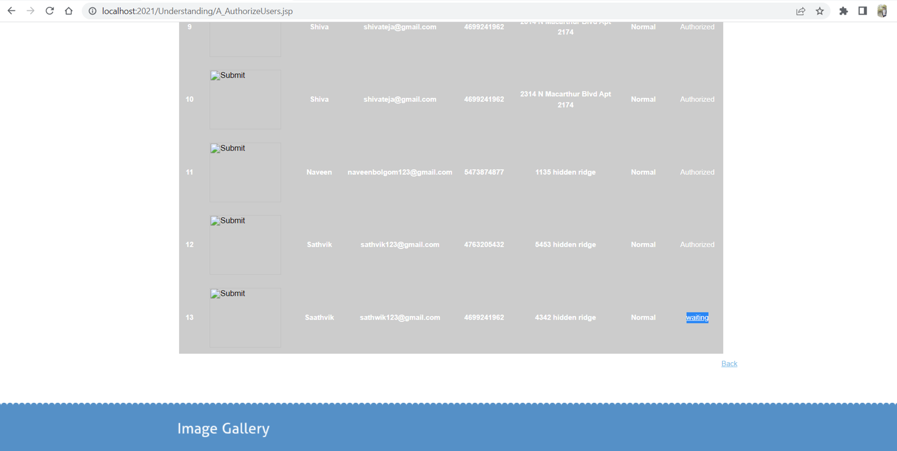

Step 9: After the successful authorization, user can login into their account.

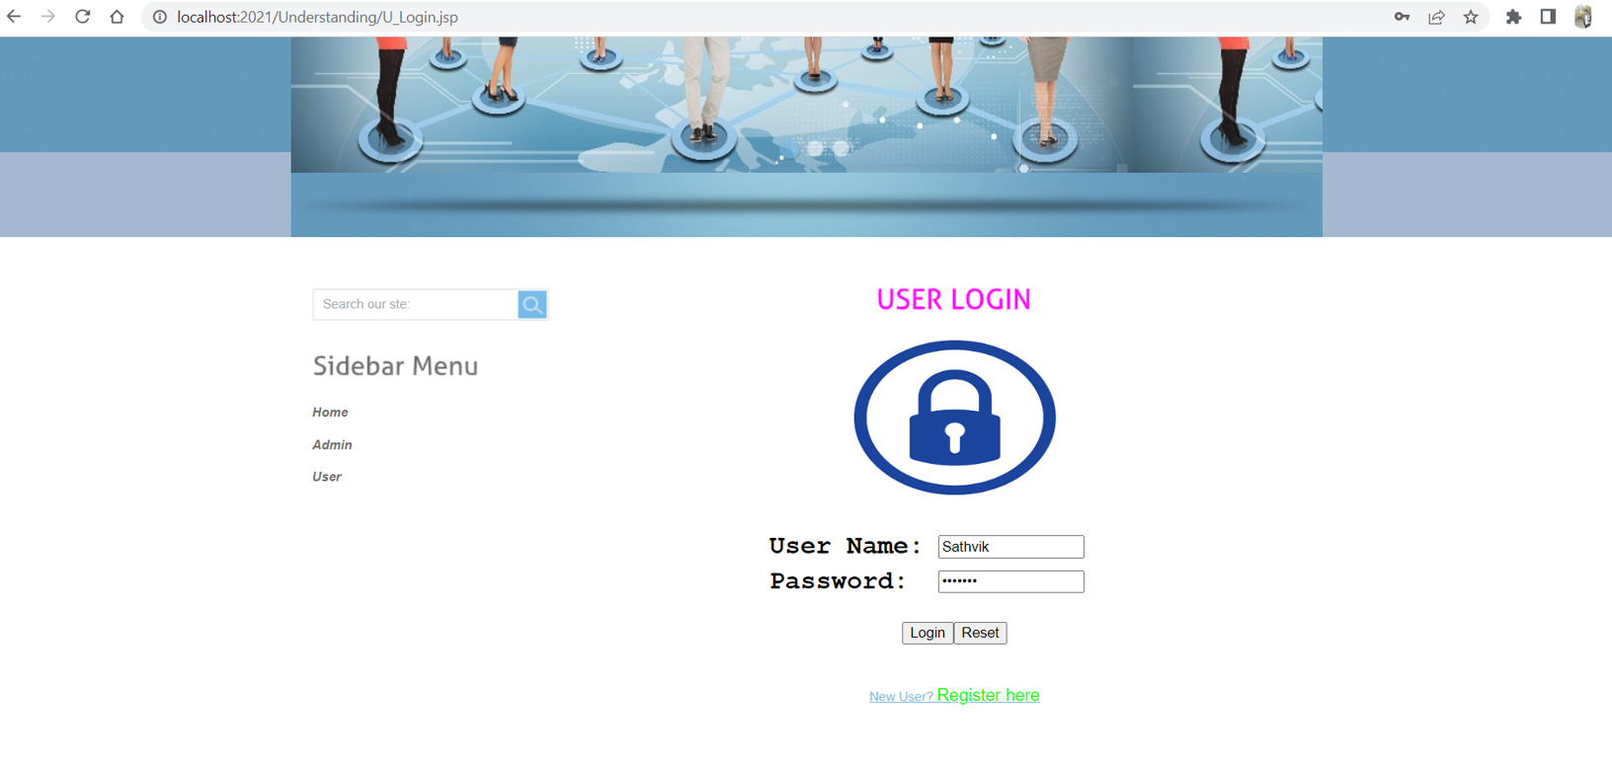

Step 10: Here is the home page of the User.

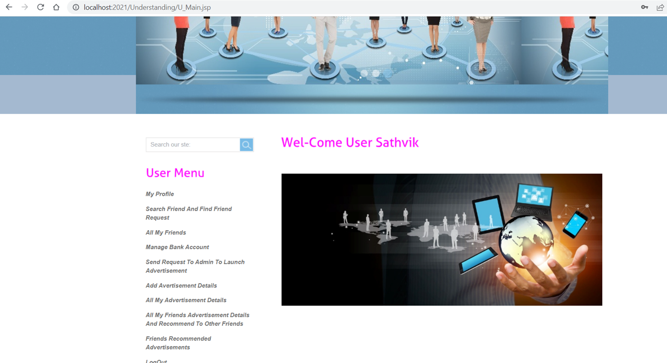

# UML Design

## Class diagram

Class diagram for “The Bug Tracking System” with respect to the Phase – 1 Requirements. 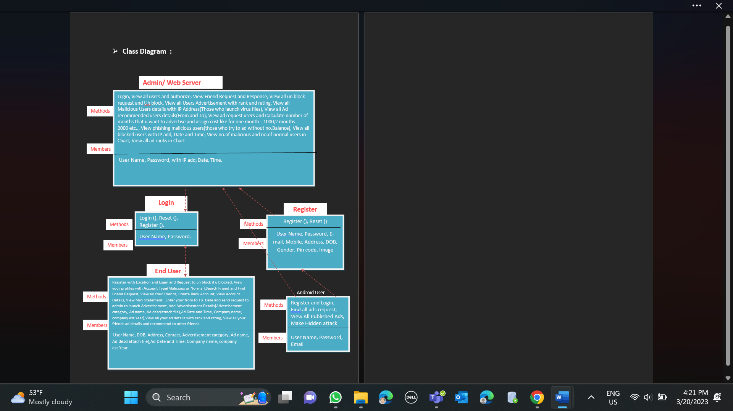

Figure : Class Diagram

## Sequence diagram

Sequence diagram for “The Bug Tracking System” with respect to the Phase – 1 Requirements.

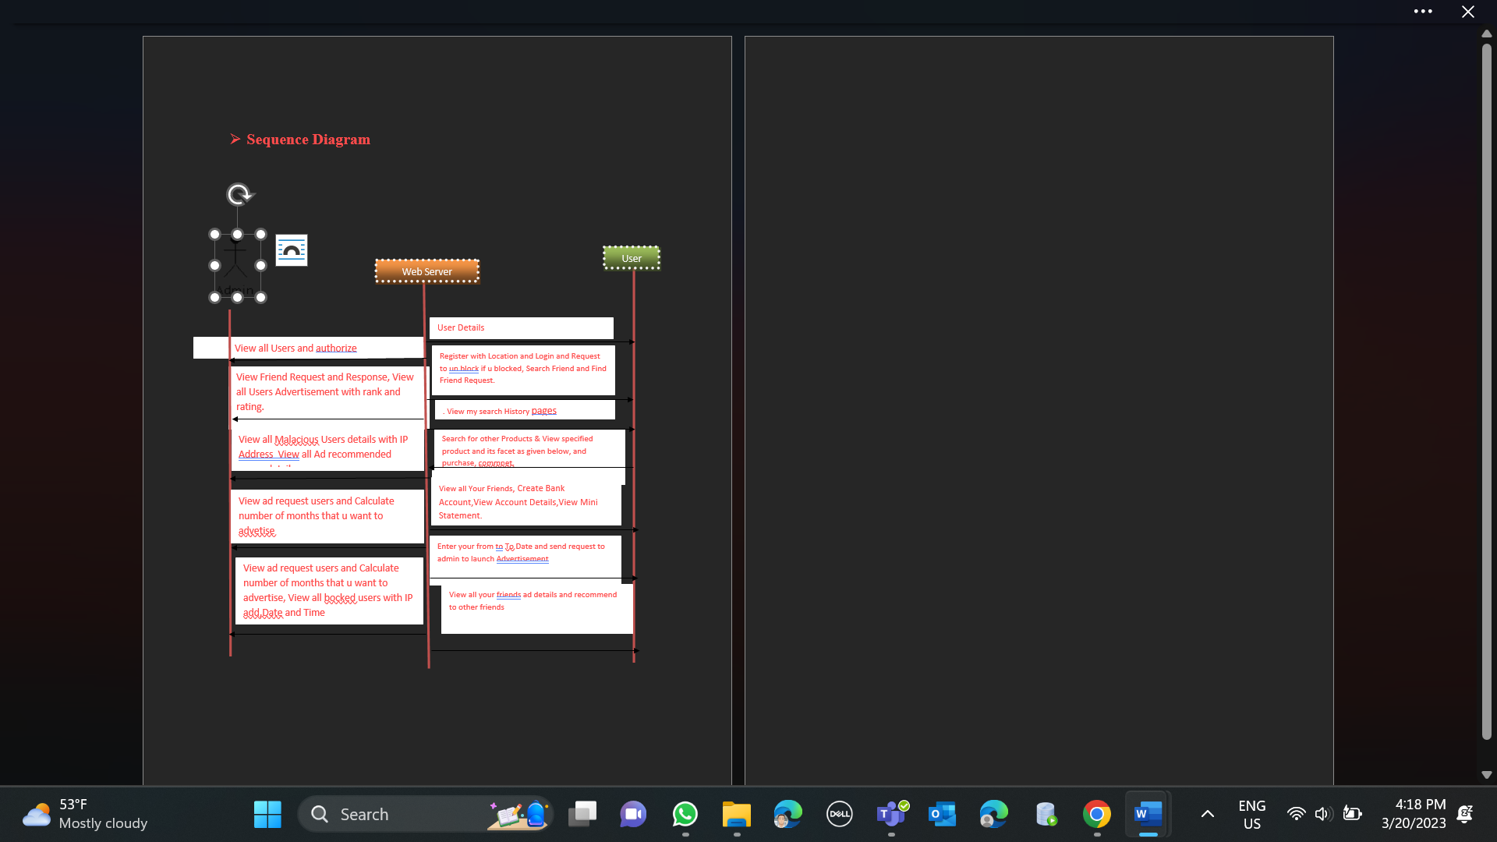

Figure : Sequence Diagram

## Use case diagram

Use Case diagram for “**Understanding In-app Ads and Detecting Hidden Attacks through the mobile App -Web Interface.**” with respect to the Phase – 1 Requirements.

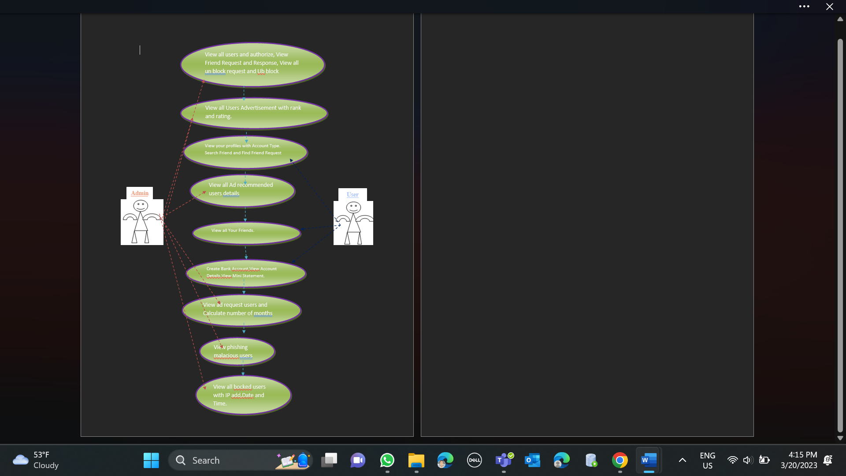

Figure : Use-case Diagram-normal case.

# Test Cases

Here If we enter the Username and Password are wrong then we will get error.

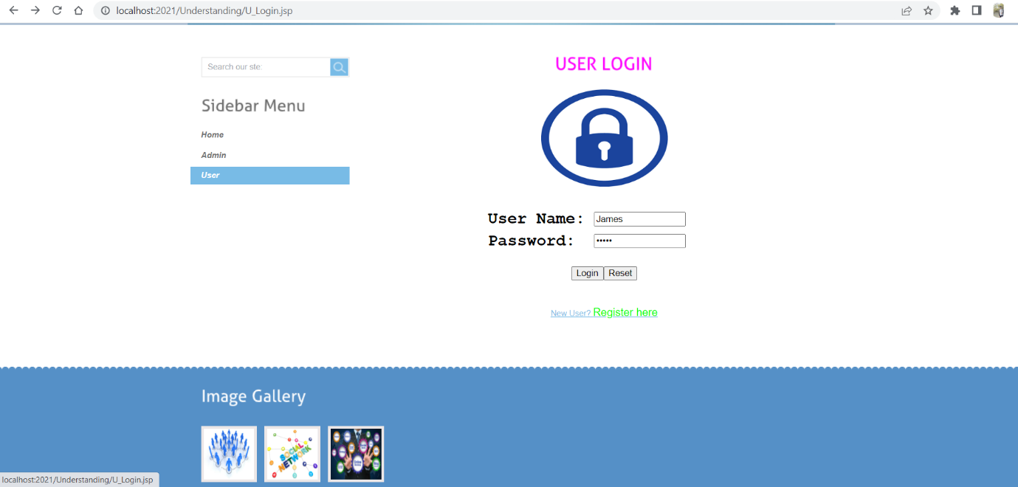

In the below screenshot error is displayed:

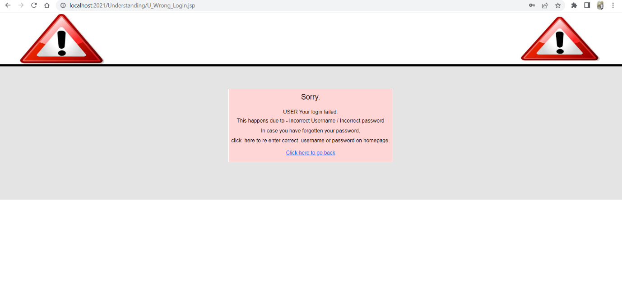

2. At the time of registering the account if we miss any important field it will generate error 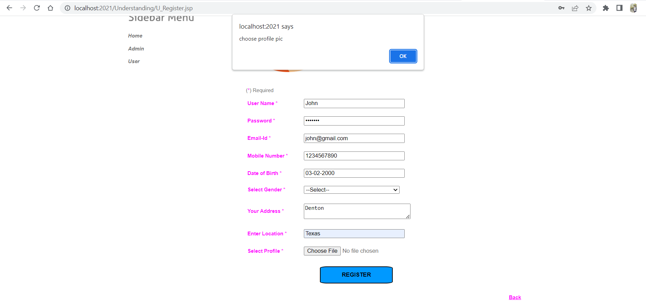

|  |  |  |  |  |
| --- | --- | --- | --- | --- |
| S.No | Test Case | Pre- Condition | Post- Condition | Result |
| 1. | User Registration | Users will be on the registration page. User will fill the details for registering their account by providing username, email, contact and other details. | After submitting the form, the user's information is saved in the database, and they can now log in using the username. | Pass |
| 2. | Login | In the login page, user going to provide their unique details to login. Here, the user can log into their account after the successful authorization. | On submitting the details user going land home page of the user if he/she provides correct details. Otherwise, it gives error. | Pass |
| 3. | View profile | User and admin can see their profile. If requires they can update. | User changed their details returned to this page. | pass |

# Program Compilation and Run Instructions

**Compilation Instructions:**

Here are step-by-step instructions for compiling and running your program and test cases. The program should first compiles and then runs.

Follow the below steps for running the code in your local system:

1. **Download Tomcat:** Go to the Apache Tomcat download page and download the latest version of Tomcat that is compatible with your operating system. Choose the Core binary distribution for your operating system and download the ZIP or TAR file.
2. **Extract the files:** Once the download is complete, extract the contents of the ZIP or TAR file to a directory of your choice. This will create a new directory containing the Tomcat files.
3. **Start the server**: To start Tomcat, navigate to the bin directory of the Tomcat directory and run the startup application named ‘Tomcat8.exe’ to start the server.

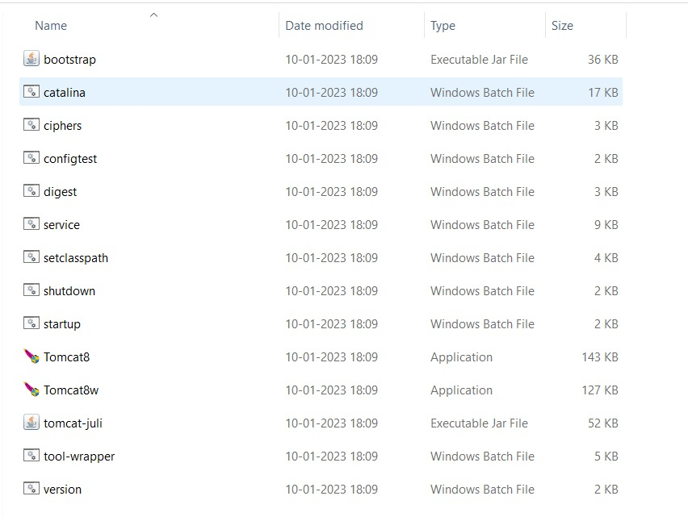

This will start the Tomcat server and make it accessible at <http://localhost:2021/> as below.

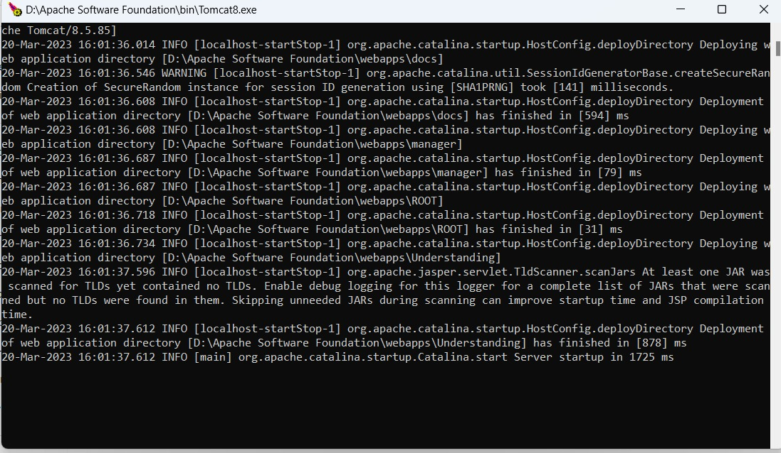

1. **Verify the installation**: To verify that Tomcat is running, open a web browser and go to http://localhost:2021/. You should see the default Tomcat home page as below.

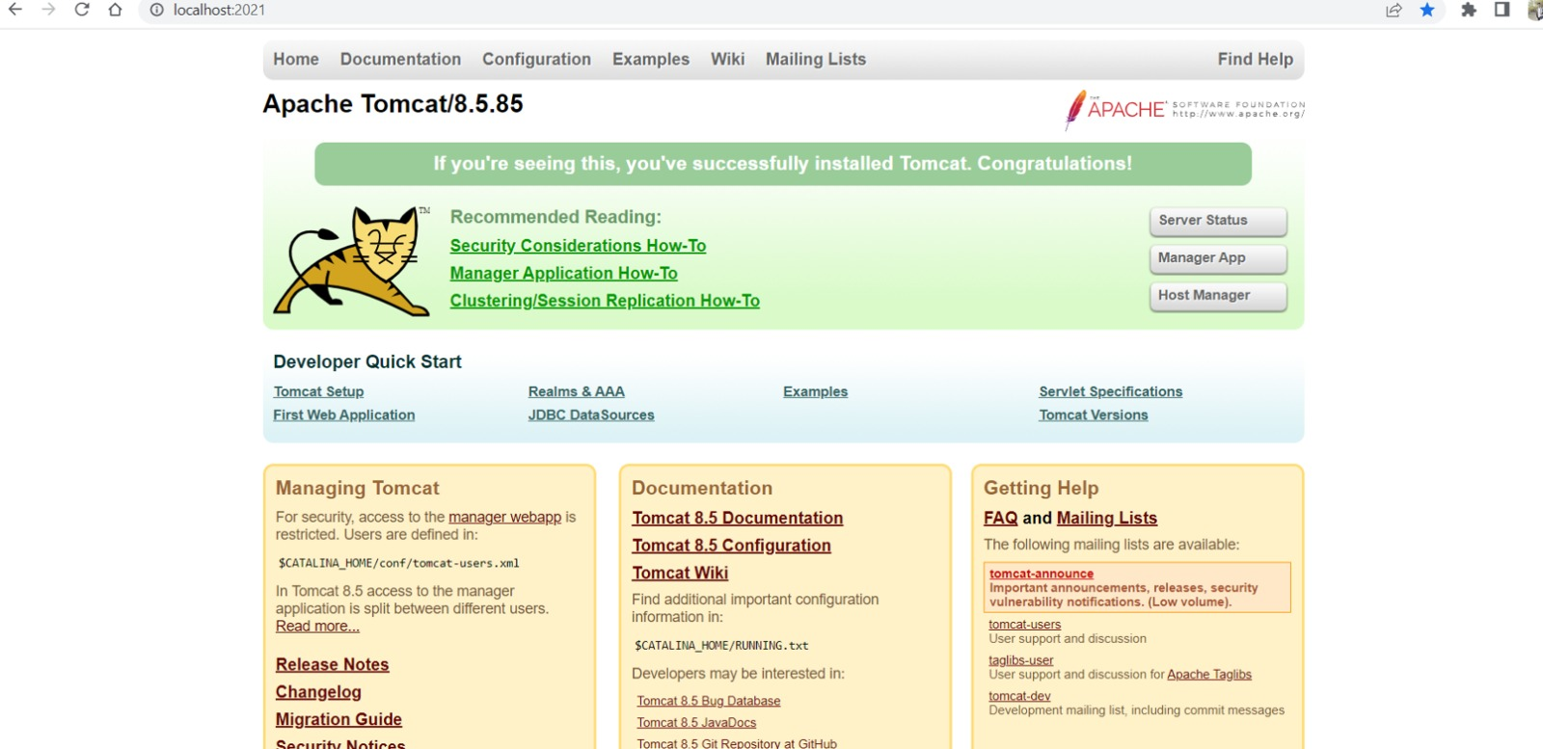

1. **Navigate to the Application**: To navigate to the home page of your application go to the manager page where all the available applications are displayed by clicking on Manager App button as below.

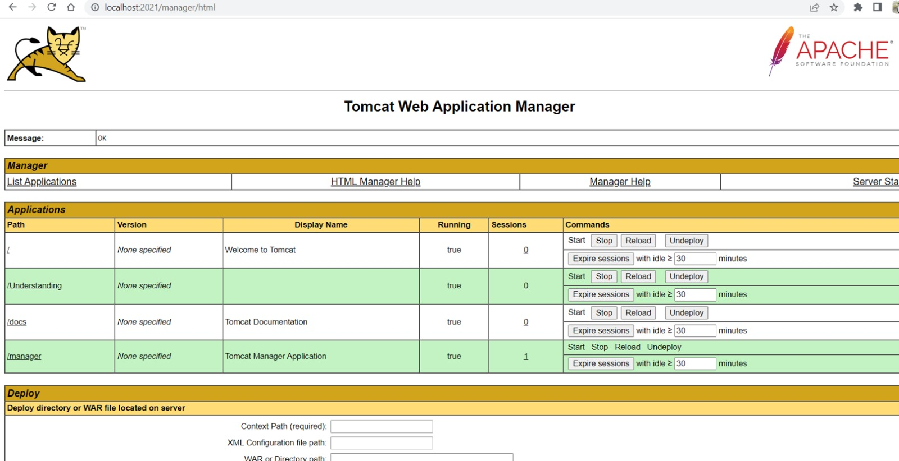

And then click on ‘/Understanding’ to go to your application’s home page as below by entering the credentials when prompted.

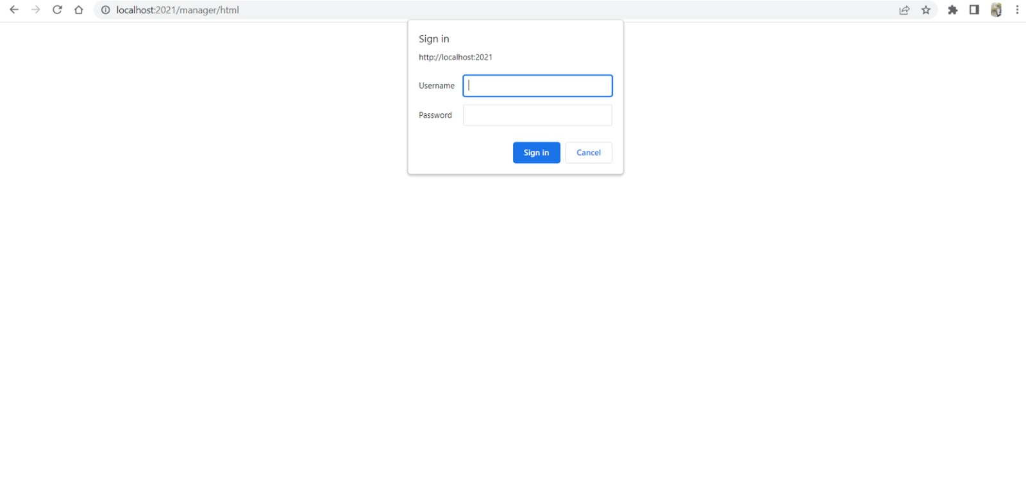

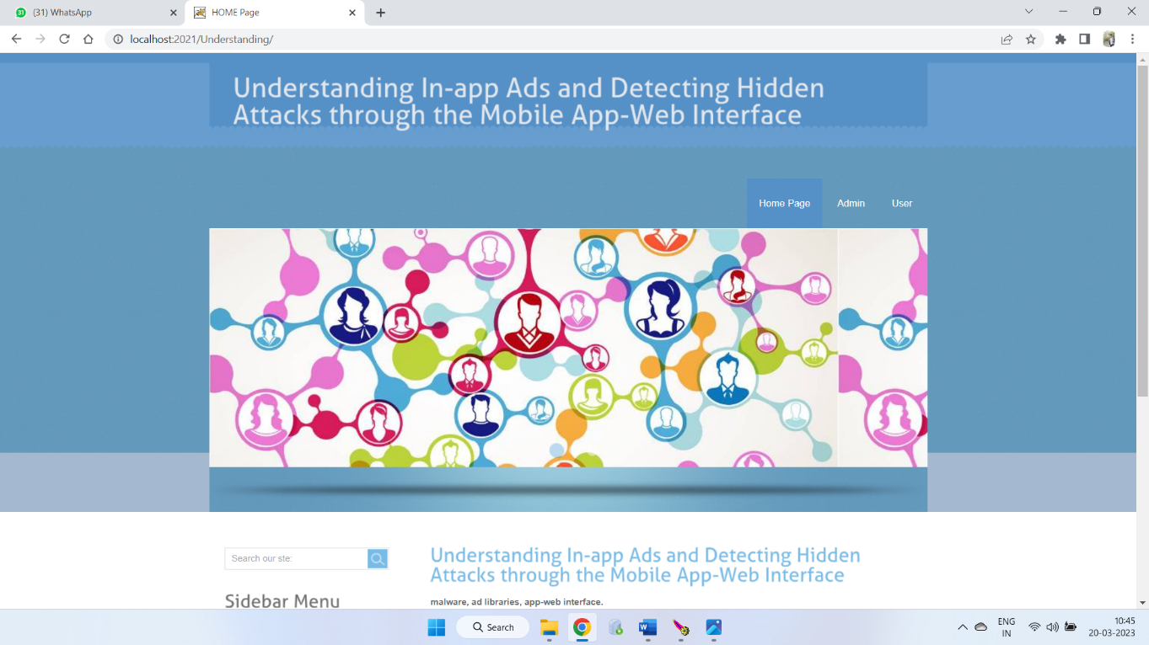

You've now successfully set up the Tomcat server and your application on your system.

1. **Closing the server**: To close Tomcat, navigate to the bin directory of the Tomcat directory and run the application named ‘Tomcat8w.exe’ to close the server.

## Testing Instructions

* 1. For testing , first setup the application based
  2. Here, The application is a web application which on browser so, we are directly executing the program on browser itself and testing every function on it.

# Feedback

Feedback received:

* Block and unblock:

If any user appears to be malicious and troublesome there should be a future of blocking and unblocking that user whenever necessary maybe permanently or temporarily.

* Direct link to bank account:

Creating another bank account explicitly only for the use of this application is a very time consuming. So instead of creating an account, linking the users account to their existing bank account will enhance the development process and reduces the human effort required for the project.

* Cost efficiency:

They have suggested us to cut down the financial cost of the project and make the project in a cost-efficient way. They are thinking that this application is used by few people, so they want to reduce the cost of the application.

Actions taken based on the feedback:

* Block and unblock
* Cost efficiency

**Rejected:**

* Direct link to bank account

Given the time constant and resources it is not feasible for the implementation of this suggestion. It will be a hectic process to get access to the APIs of the bank account as they are highly confidential and expensive.

# Accomplishments

A complete explanation what we accomplished in this phase of the project and what we are trying to work on:

1. Created and developed Database and the records in it to run the application successful manner.

We are completely using Oracle as a Database in our project. We added necessary tables to maintain good flow in all the domains.

1. Developed the application layer for the webpage using Java.

We have used java servlet pages for Application layer development, which helps in faster working of pages and functionalities.

1. Developed front end webpages for all the modules with minimum functionalities to them using following technologies.

We used Ajax, jQuery and Servlet pages for the developing part for backend.

1. Connected and integrated the database and the front-end part using Ajax, JavaScript and Java.
2. We worked on backend part for performing Admin, User and Android modules flow for the functionalities being integrated to the system’s database and other architecture.

Here we had some training sessions among the team for helping each other on understanding the backend as everyone is not familiar with that.

1. Went for Initial Testing:

The application first deployed using Apache tomcat server and performed initial testing.

# Member contribution table

|  |  |  |  |
| --- | --- | --- | --- |
| **Member Name** | **Contribution Description** | **Overall Contribution (%)** | **Note (If Applicable)** |
| **Sushma Bobbishetty** | Functional and Non-Functional requirement specification and Full Stack Development, worked on all components. | 15 |  |
| **Sathvik Cheekati** | Program Compilation and Run Instructions. Front-end development of customer, employee, and manager modules. | 16 |  |
| **Navyasri Arekatla** | Test Cases and Back-end development of customer, employee, and manager modules. | 12 |  |
| **Naveen Bolgom** | Feedback and accomplishments. Back-end development of customer, employee, and manager modules. | 12 |  |
| **Lokesh Bachu** | Code-inspection document. Front-end development of customer, employee, and manager modules. | 15 |  |
| **Vamshi Teja Goud Puli** | User Manual and Application Layer Development. UML Designs and Initial Integrated Testing. | 13 |  |
| **Shiva Teja Reddy Yammanuru** | Code-inspection document and GitHub update and Application and UI Development. | 15 |  |